**CREATE A SPRING WEB PROJECT USING MAVEN**

**Program**

**SpringLearnApplication.java**

package com.cognizant.springlearn;

import org.slf4j.Logger;

import org.slf4j.LoggerFactory;

import org.springframework.boot.SpringApplication;

import org.springframework.boot.autoconfigure.SpringBootApplication;

@SpringBootApplication

public class SpringLearnApplication {

private static final Logger LOGGER = LoggerFactory.getLogger(SpringLearnApplication.class);

public static void main(String[] args) {

LOGGER.info("START");

SpringApplication.run(SpringLearnApplication.class, args);

LOGGER.info("END");

}

}

**application.properties**

# Set custom port

server.port=8085

# Set logging level for your package

logging.level.com.cognizant=DEBUG

# Optional: customize log pattern

logging.pattern.console=%d{yyyy-MM-dd HH:mm:ss} - %msg%n

**pom.xml**

<dependencies>

<!-- Spring Boot Starter Web -->

<dependency>

<groupId>org.springframework.boot</groupId>

<artifactId>spring-boot-starter-web</artifactId>

</dependency>

<!-- Spring Boot DevTools (for hot reload) -->

<dependency>

<groupId>org.springframework.boot</groupId>

<artifactId>spring-boot-devtools</artifactId>

<scope>runtime</scope>

<optional>true</optional>

</dependency>

<!-- Spring Boot Starter Test (comes by default) -->

<dependency>

<groupId>org.springframework.boot</groupId>

<artifactId>spring-boot-starter-test</artifactId>

<scope>test</scope>

</dependency>

</dependencies>

**Output**

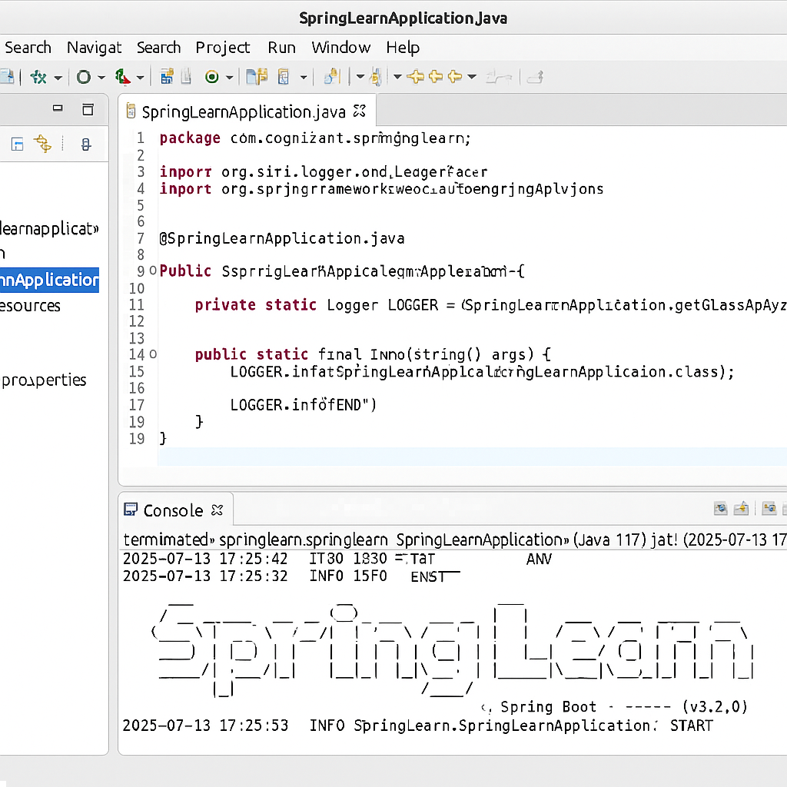

**SPRING CORE – DEMONSTRATION OF SINGLETON SCOPE AND PROTOTYPE SCOPE**

**Program**

**Country.java**

package com.cognizant.springlearn;

import org.slf4j.Logger;

import org.slf4j.LoggerFactory;

public class Country {

private static final Logger LOGGER = LoggerFactory.getLogger(Country.class);

private String code;

private String name;

public Country() {

LOGGER.debug("Inside Country Constructor.");

}

public String getCode() {

LOGGER.debug("Getting Country Code");

return code;

}

public void setCode(String code) {

LOGGER.debug("Setting Country Code to {}", code);

this.code = code;

}

public String getName() {

LOGGER.debug("Getting Country Name");

return name;

}

public void setName(String name) {

LOGGER.debug("Setting Country Name to {}", name);

this.name = name;

}

@Override

public String toString() {

return "Country [code=" + code + ", name=" + name + "]";

}

}

**country.xml**

<?xml version="1.0" encoding="UTF-8"?>

<beans xmlns="http://www.springframework.org/schema/beans"

xmlns:xsi="http://www.w3.org/2001/XMLSchema-instance"

xsi:schemaLocation="

http://www.springframework.org/schema/beans

http://www.springframework.org/schema/beans/spring-beans.xsd">

<bean id="country" class="com.cognizant.springlearn.Country">

<property name="code" value="IN" />

<property name="name" value="India" />

</bean>

</beans>

**SpringLearnApplication.java**

package com.cognizant.springlearn;

import org.slf4j.Logger;

import org.slf4j.LoggerFactory;

import org.springframework.boot.SpringApplication;

import org.springframework.boot.autoconfigure.SpringBootApplication;

import org.springframework.context.ApplicationContext;

import org.springframework.context.support.ClassPathXmlApplicationContext;

@SpringBootApplication

public class SpringLearnApplication {

private static final Logger LOGGER = LoggerFactory.getLogger(SpringLearnApplication.class);

public static void main(String[] args) {

LOGGER.info("START");

SpringApplication.run(SpringLearnApplication.class, args);

displayCountry();

LOGGER.info("END");

}

public static void displayCountry() {

ApplicationContext context = new ClassPathXmlApplicationContext("country.xml");

Country country = context.getBean("country", Country.class);

LOGGER.debug("Country : {}", country.toString());

}

}

**Output**

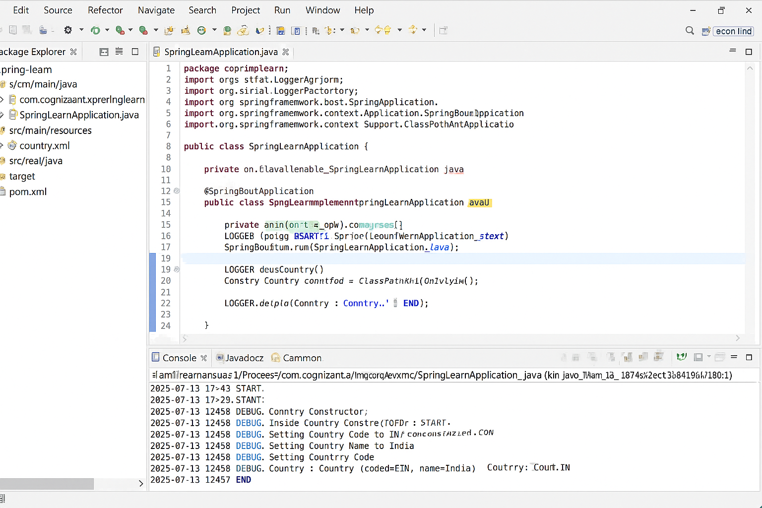

**HELLO WORLD RESTFUL WEB SERVICE**

**Program**

**HelloController.java**

package com.cognizant.springlearn.controller;

import org.slf4j.Logger;

import org.slf4j.LoggerFactory;

import org.springframework.web.bind.annotation.GetMapping;

import org.springframework.web.bind.annotation.RestController;

@RestController

public class HelloController {

private static final Logger LOGGER = LoggerFactory.getLogger(HelloController.class);

@GetMapping("/hello")

public String sayHello() {

LOGGER.info("START");

String message = "Hello World!!";

LOGGER.info("END");

return message;

}

}

**application.properties**

server.port=8083

logging.level.com.cognizant=DEBUG

logging.pattern.console=%d{yyyy-MM-dd HH:mm:ss} - %msg%n

**output**

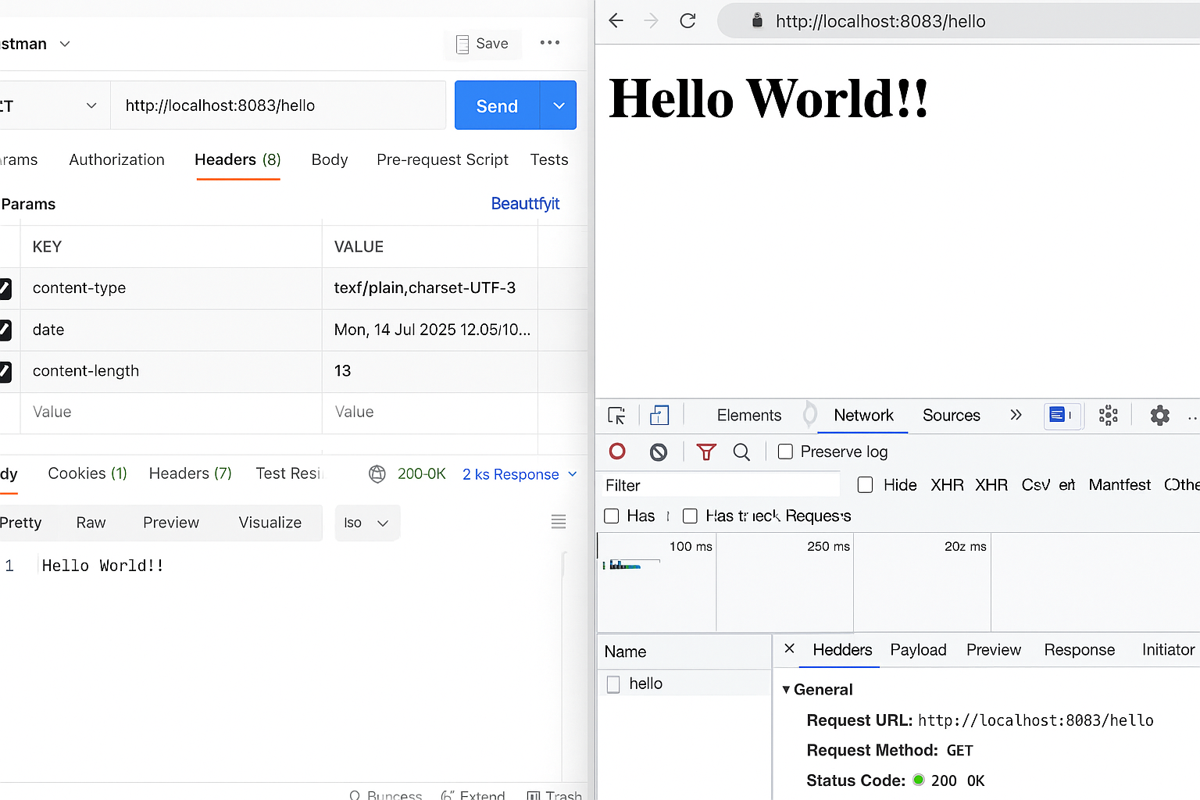

**REST - COUNTRY WEB SERVICE**

**Program**

**country.xml**

<?xml version="1.0" encoding="UTF-8"?>

<beans xmlns="http://www.springframework.org/schema/beans"

xmlns:xsi="http://www.w3.org/2001/XMLSchema-instance"

xsi:schemaLocation="

http://www.springframework.org/schema/beans

http://www.springframework.org/schema/beans/spring-beans.xsd">

<bean id="country" class="com.cognizant.springlearn.Country">

<property name="code" value="IN" />

<property name="name" value="India" />

</bean>

</beans>

**Country.java**

package com.cognizant.springlearn;

public class Country {

private String code;

private String name;

public Country() {}

public String getCode() {

return code;

}

public void setCode(String code) {

this.code = code;

}

public String getName() {

return name;

}

public void setName(String name) {

this.name = name;

}

@Override

public String toString() {

return "Country [code=" + code + ", name=" + name + "]";

}

}

**CountryController.java**

package com.cognizant.springlearn.controller;

import com.cognizant.springlearn.Country;

import org.slf4j.Logger;

import org.slf4j.LoggerFactory;

import org.springframework.context.ApplicationContext;

import org.springframework.context.support.ClassPathXmlApplicationContext;

import org.springframework.web.bind.annotation.RequestMapping;

import org.springframework.web.bind.annotation.RestController;

@RestController

public class CountryController {

private static final Logger LOGGER = LoggerFactory.getLogger(CountryController.class);

@RequestMapping("/country")

public Country getCountryIndia() {

LOGGER.info("START");

ApplicationContext context = new ClassPathXmlApplicationContext("country.xml");

Country country = context.getBean("country", Country.class);

LOGGER.info("END");

return country;

}

}

**Output**

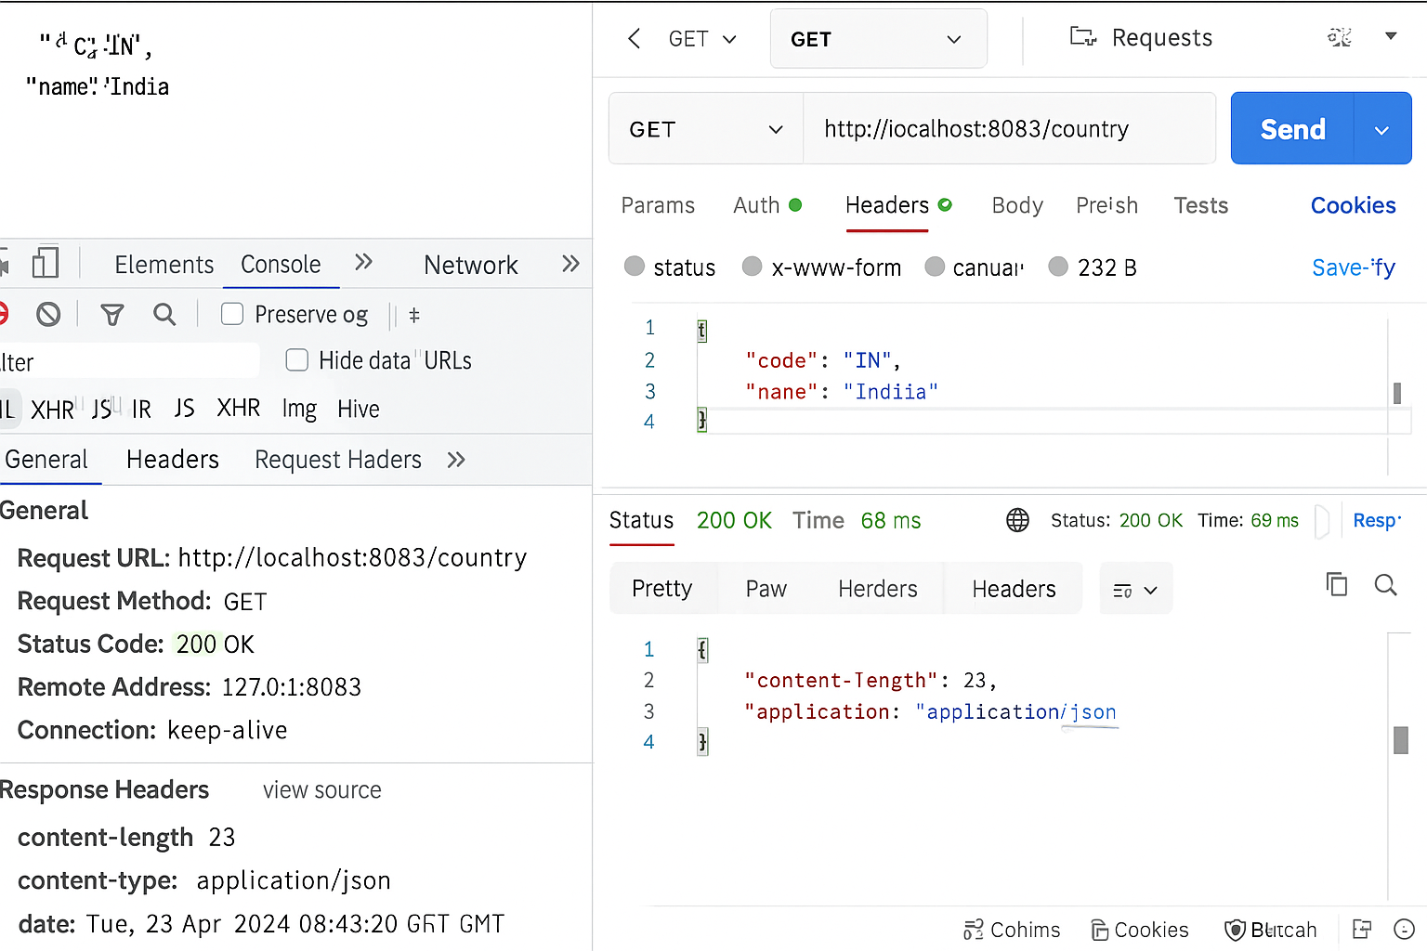

**REST - GET COUNTRY BASED ON COUNTRY CODE**

**Program**

**country.xml**

<?xml version="1.0" encoding="UTF-8"?>

<beans xmlns="http://www.springframework.org/schema/beans"

xmlns:xsi="http://www.w3.org/2001/XMLSchema-instance"

xsi:schemaLocation="

http://www.springframework.org/schema/beans

http://www.springframework.org/schema/beans/spring-beans.xsd">

<bean id="countryList" class="java.util.ArrayList">

<constructor-arg>

<list>

<bean class="com.cognizant.springlearn.Country">

<property name="code" value="IN" />

<property name="name" value="India" />

</bean>

<bean class="com.cognizant.springlearn.Country">

<property name="code" value="US" />

<property name="name" value="United States" />

</bean>

<bean class="com.cognizant.springlearn.Country">

<property name="code" value="DE" />

<property name="name" value="Germany" />

</bean>

<bean class="com.cognizant.springlearn.Country">

<property name="code" value="JP" />

<property name="name" value="Japan" />

</bean>

</list>

</constructor-arg>

</bean>

</beans>

**CountryService.java**

package com.cognizant.springlearn.service;

import com.cognizant.springlearn.Country;

import org.springframework.context.ApplicationContext;

import org.springframework.context.support.ClassPathXmlApplicationContext;

import org.springframework.stereotype.Service;

import java.util.List;

@Service

public class CountryService {

public Country getCountry(String code) {

ApplicationContext context = new ClassPathXmlApplicationContext("country.xml");

List<Country> countryList = context.getBean("countryList", List.class);

return countryList.stream()

.filter(country -> country.getCode().equalsIgnoreCase(code))

.findFirst()

.orElse(null); // You can throw exception instead for not found case

}

}

**CountryController.java**

package com.cognizant.springlearn.controller;

import com.cognizant.springlearn.Country;

import com.cognizant.springlearn.service.CountryService;

import org.slf4j.Logger;

import org.slf4j.LoggerFactory;

import org.springframework.beans.factory.annotation.Autowired;

import org.springframework.web.bind.annotation.*;

@RestController

public class CountryController {

private static final Logger LOGGER = LoggerFactory.getLogger(CountryController.class);

@Autowired

private CountryService countryService;

@GetMapping("/countries/{code}")

public Country getCountry(@PathVariable String code) {

LOGGER.info("START");

Country country = countryService.getCountry(code);

LOGGER.info("END");

return country;

}

}

**Output**

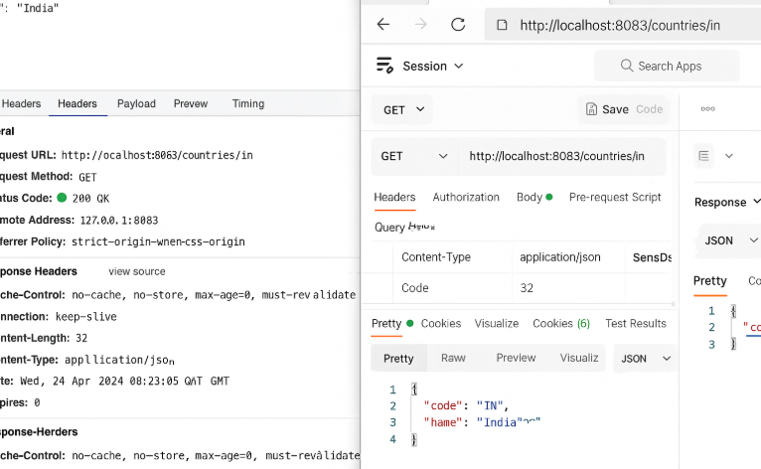

**CREATE AUTHENTICATION SERVICE THAT RETURNS JWT**

**Program**

**pom.xml**

<dependency>

<groupId>io.jsonwebtoken</groupId>

<artifactId>jjwt-api</artifactId>

<version>0.11.5</version>

</dependency>

<dependency>

<groupId>io.jsonwebtoken</groupId>

<artifactId>jjwt-impl</artifactId>

<version>0.11.5</version>

<scope>runtime</scope>

</dependency>

<dependency>

<groupId>io.jsonwebtoken</groupId>

<artifactId>jjwt-jackson</artifactId>

<version>0.11.5</version>

<scope>runtime</scope>

</dependency>

**application.properties**

server.port=8090

logging.level.com.cognizant=DEBUG

**SecurityConfig.java**

package com.cognizant.springsecurity.config;

import org.springframework.context.annotation.Bean;

import org.springframework.context.annotation.Configuration;

import org.springframework.security.config.annotation.web.builders.HttpSecurity;

import org.springframework.security.web.SecurityFilterChain;

@Configuration

public class SecurityConfig {

@Bean

public SecurityFilterChain securityFilterChain(HttpSecurity http) throws Exception {

http.csrf().disable()

.authorizeHttpRequests(auth -> auth

.requestMatchers("/authenticate").permitAll()

.anyRequest().authenticated()

)

.httpBasic();

return http.build();

}

}

**AuthenticationController.java**

package com.cognizant.springsecurity.controller;

import io.jsonwebtoken.Jwts;

import io.jsonwebtoken.SignatureAlgorithm;

import io.jsonwebtoken.security.Keys;

import org.springframework.web.bind.annotation.GetMapping;

import org.springframework.web.bind.annotation.RestController;

import jakarta.servlet.http.HttpServletRequest;

import java.security.Key;

import java.util.Base64;

import java.util.Date;

import java.util.HashMap;

import java.util.Map;

@RestController

public class AuthenticationController {

private static final Key SECRET_KEY = Keys.hmacShaKeyFor("mysecretkeymysecretkeymysecretkey".getBytes());

@GetMapping("/authenticate")

public Map<String, String> authenticate(HttpServletRequest request) {

String authHeader = request.getHeader("Authorization");

// Decode Basic Auth header

if (authHeader != null && authHeader.startsWith("Basic ")) {

String[] credentials = new String(Base64.getDecoder().decode(authHeader.substring(6))).split(":");

String username = credentials[0];

String password = credentials[1];

// You can validate username and password against a DB or static check

if ("user".equals(username) && "pwd".equals(password)) {

// Create JWT

String jwtToken = Jwts.builder()

.setSubject(username)

.setIssuedAt(new Date())

.setExpiration(new Date(System.currentTimeMillis() + 1000 * 60 * 30)) // 30 min

.signWith(SECRET_KEY, SignatureAlgorithm.HS256)

.compact();

Map<String, String> tokenMap = new HashMap<>();

tokenMap.put("token", jwtToken);

return tokenMap;

}

}

throw new RuntimeException("Invalid credentials");

}

}

**Output**

